“Unhooked from Time” at Gallery Project
Date: May 1, 2011
Author: Clara DeGalan
in thedetroiter.com

Gallery project puts together shows with themes that are broad, relate-able, and always slyly zeitgeist. The ideas presented are ones you find have been swimming around in your head for a minute, given expression. When that happens, well, it’s like being hooked up to an IV of the culture. It’s an eerie, great feeling. The work on display at Gallery Project may not all be stellar, but it’s always hyper-sensitive to the strings being plucked in the common soul. And what’s more current an issue now, for artists and non-artists alike, than time? The very fabric of it is shifting beneath our feet. Because of technology, exploding worldwide population, and rash use of resources we’re only beginning to realize are limited, the way we Westerners have always conceived time must change, and is. Gallery Project’s new show, “Unhooked from Time,” explores this unfolding revolution on many different levels, from the bones of technology to the campily symbolic to the high, silent spiritual to the common savor of nostalgia that bubbles up bittersweet.

“Unhooked from Time” has a lot of work in a wide gamut of media, but it really gets rolling with its photos and films. I was a little disappointed in the non-photographic 2D work on offer. Jennilie Brewster’s collage paintings, Bomb and Nuclear have intriguing components, where gaps in the dense crosshatching and slashes dug in the paint look like worm tunnels, and in her rusty, post-apocalyptic palette. The other paintings in the show don’t lack for magical ideas (Renata Palubinskas’s two petite oils, Girl and Bird and Desecration 2 have the ring of tempera illuminations from a Fifteenth Century book of hours, but feel a little stiff and dusty because of that), but none of them really came together for me. There were two fine, solemn drawings by Carolyn Reed Barritt that channeled time through nostalgia and loss. Each drawing depicts a worn out doll looming out of deep shadow like poignant, friendly ghosts.

The flower-patterned hide of the button-eyed Floral Horse blends with the patterned wallpaper in the background as if fading into the backlogs of memory; one hoof wears a sad little shoe which almost made me cry. “Unhooked from Time” is rich with good drawings; Nicole Gordon and Brent Fogt’s large drawings on mylar, Asylum and Oak respectively, deserve to be lingered over for their elaborate, butter-smooth surfaces.

I love art made with computer circuit boards. There’s something that’s just cool about them, with their technicolor green hue out of a Diebenkorn landscape and their eerie resemblance to city grids- the grids that make our macro-cosmic grids go. A wall-sized, back lit installation of circuit boards by Charles Jevremovic reads like a winking mini-city, and speaks of the technological detritus that mounts behind us as we march toward ever finer, tinier circuits.

It seems no show is complete nowadays without the obligatory huge pile of garbage installation that maybe sticks around because it’s relevant in the rust belt (unfortunately), but “Unhooked from Time’s” offering, by Andrew Thompson and Scotty Wagner, Seen and Unseen, has something extra- peek into the yellow viewing portal that’s almost hidden in its bulky side to find out what.

Photography and film may be the media best suited to dialog on the nature of time, since time is such a factor in their production. Ginny Makis’s ink jet prints of satellite images of a city with blue highlighted trails look like torturous treasure maps, and feel like time lost scurrying from here to there. Time flexes its muscles in lapse, flash and decay in Caleb Charland’s amazing photographs, which mix formal beauty with technical magic tricks to create stunning, cerebral pictures- most magically of all- entirely photo shop-free. His green, gold and silver shots of moldy packaging elevate fungus to regal status. A time-lapse shot of a lit match careening through the air in a perfect arc to alight upon a waiting candle on the floor is sleight of hand broken down to its second by second process, reflected in the painstaking technical process of photographing it. My favorite of Charland’s pictures, Silhouette with Matches, carves an empty body shape into a shower of golden sparks against a grassy landscape, like a quick snapshot of a forest god, taken just as he disappears.

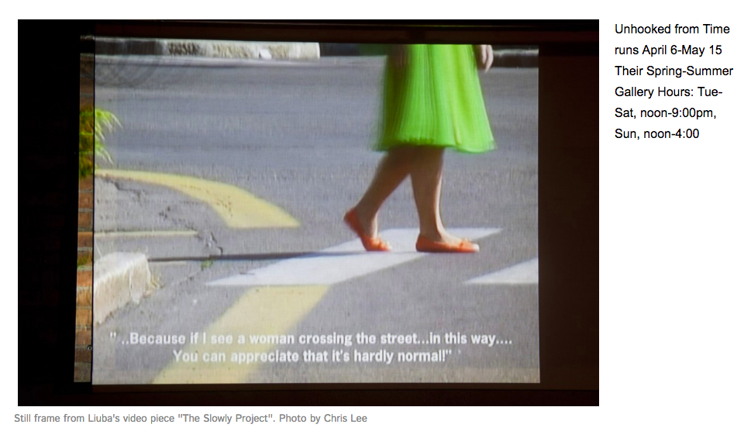
“Unhooked from Time” has a bunch of fun films on display, all of which combine humor and profundity with varying results. The standout is The Slowly Project, by a Milan and New York based artist named Liuba. It follows the artist, dressed in a gauzy green frock, walking with exaggerated slowness through urban areas in Italy and New York. The soundtrack includes the reactions of people on the street who see her, and find her bemusing, charming, and irritating by turns. To me, Liuba is spellbinding. Her anachronistic, dreamy loveliness and graceful, slow motion movements speak not only on our world’s frantic pace but on what opens up when something occurs to break that pace, causing people to stop, look, and awaken to new possibilities.

